Github link:
Web App: https://st10058999.azurewebsites.net

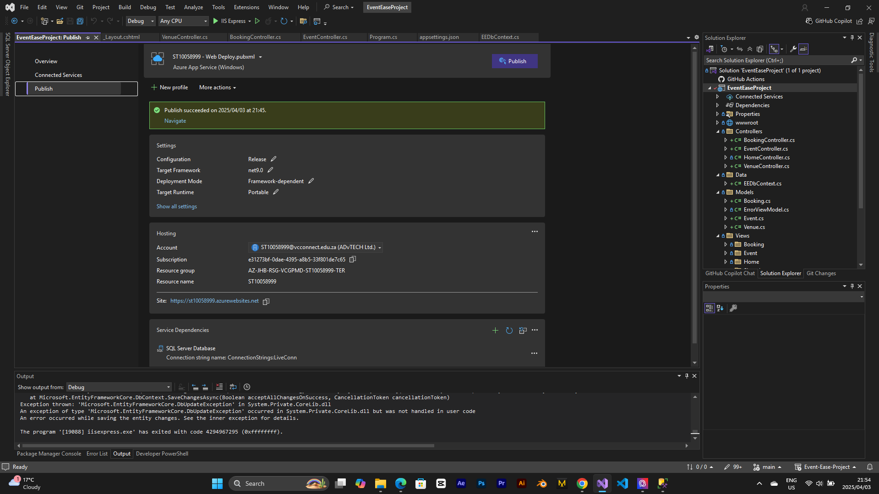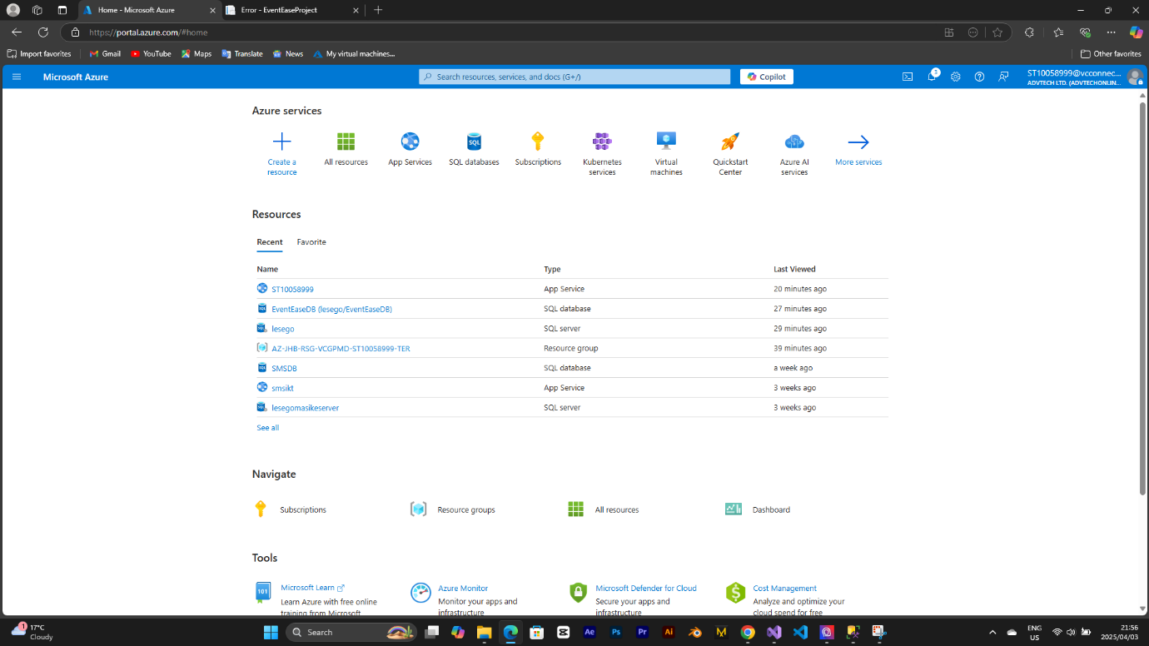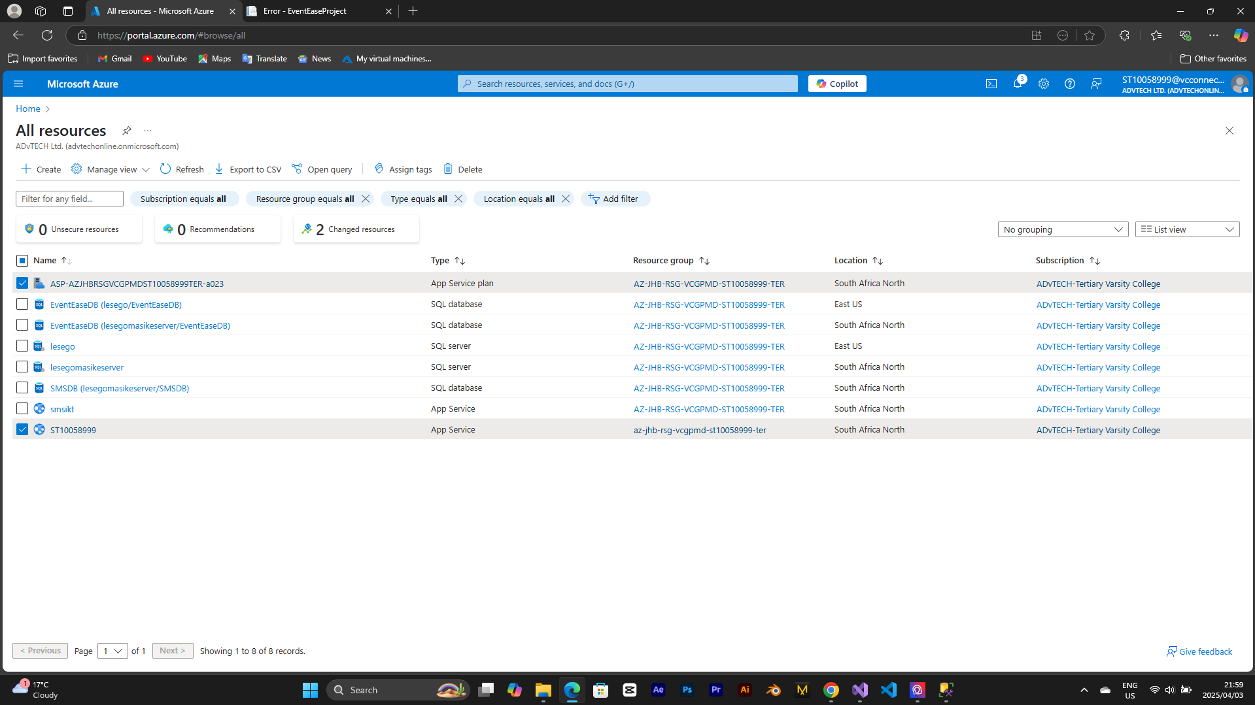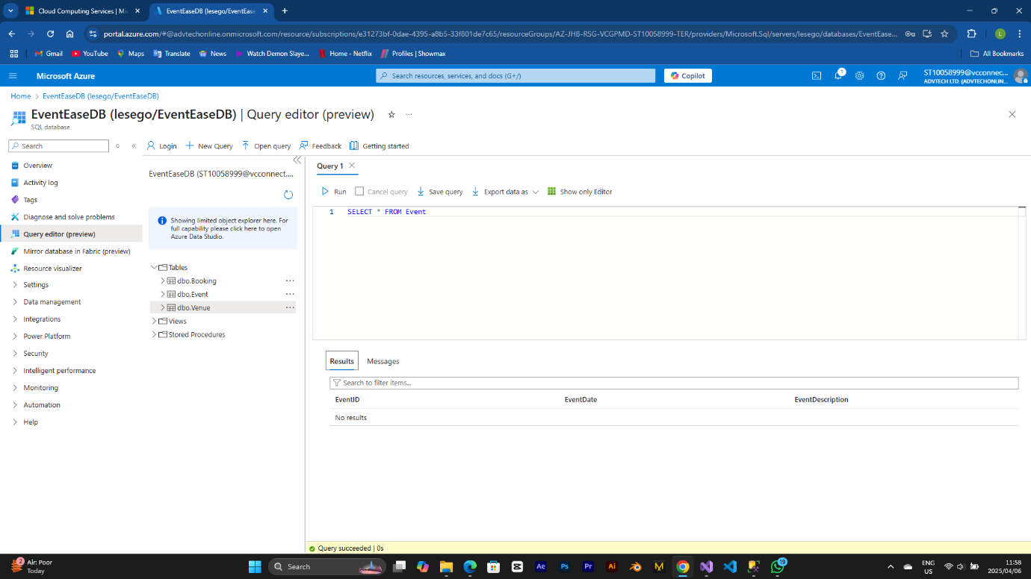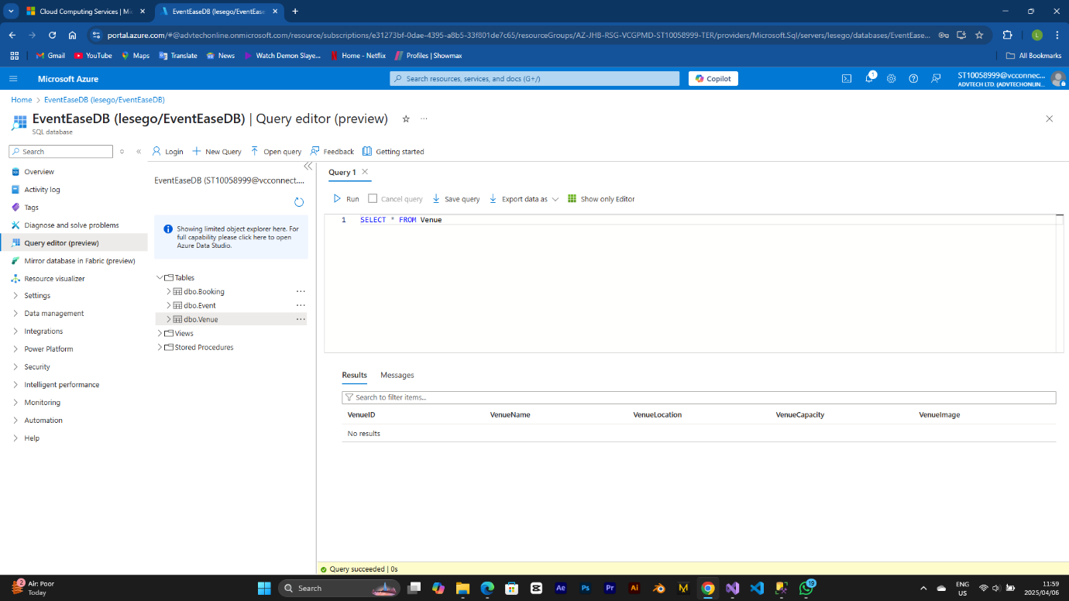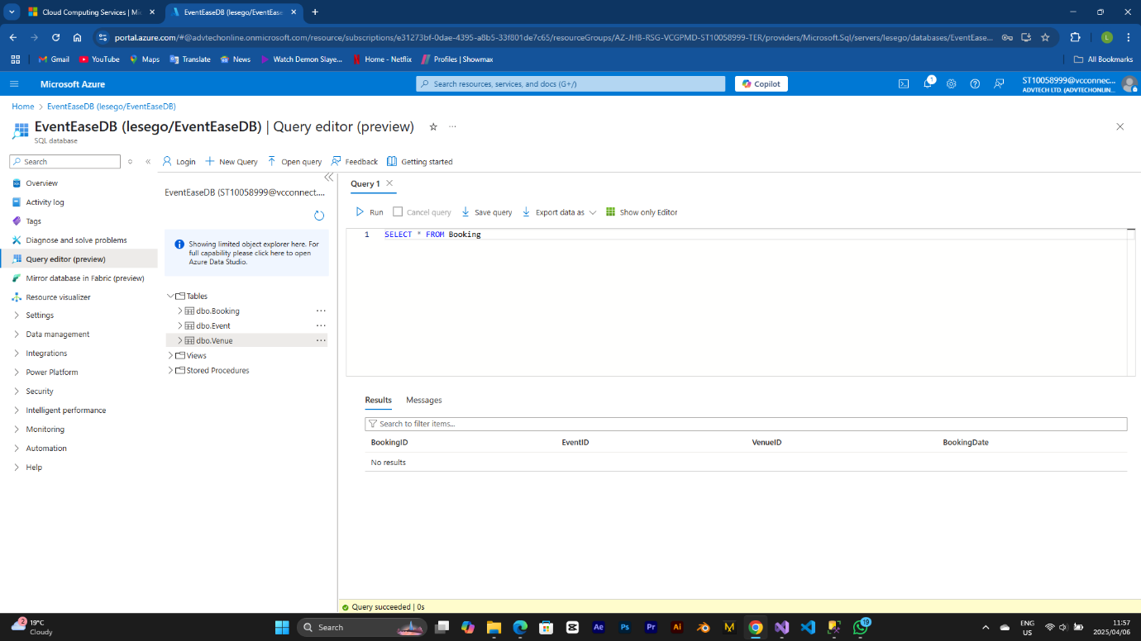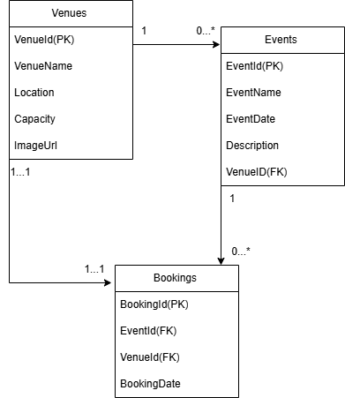

1. On-premises vs. Cloud Deployment
Question: How is the development of a cloud application not the same as the deployment of an on-premises application, and what are the differences in security, deployment speed, and resource management? Give examples to explain your answers.
Answer:
• Security:
• Cloud:Azure services like encryption, firewalls, protection against Distributed Denial of Services (DDoS), and certifications like ISO 27001 are some of the ways the cloud is secured. For example, Azure SQL Database is encrypted by default when data is at rest and in motion, hence the requirement of the EventEase team is less to secure the data storage. Things like open firewall rules are config mistakes that can be addressed (NordLayer, n.d.).
• On-Premises: the company needs to be in control of security and invest in hardware and software and hire experts. As an example: the company will be expected to be the owner and the caretaker of the hardware and software, and the primary carrier of threats, which in principle are cost and complexity increasing factors(NordLayer, n.d.).
• Speed of Deployment:
• Cloud: The configuration is automatically done, and services are already set up, and deployment is done very quickly. An example is EventEase, whose application has been published in Azure App Service via the VSTS directly (without any other physical server involvement) and the process took merely a few minutes.
• On-Premises: The process of installing hardware and setting up the environment is quite long, which makes the deployment speed slower than the other platforms. One typical example of setting up an on-premises EventEase application is buying the servers, installing software programs, and establishing networks, which can be time-consuming and take a few weeks to complete (Gupta, 2023).
• Resource Management:
• Cloud:Provides the opportunity to obtain computer time without queue, putting money only when the opportunity is used, so the costs are kept as low as possible.
For instance, EventEase is able to scale its Azure App Service plan up when there is a need for the extra computing power (e.g., Christmas and other significant holidays) and then scale it down during light usage periods in order to be cost effective (Ju-Shim, 2025).
• On-Premises: Resources are locked in a place, over or under provisioned. For example EventEase can buy extra servers to serve peak loads but these will be idle during the rest of the year as an expense.
2. IaaS, PaaS, and S Users need to understand how IaaS stands apart from PaaS and SaaS along with the rationale that PaaS matches EventEase requirements more successfully than IaaS or SaaS.
The development of a new application at EventEase benefits more from Platform as a Service than either Infrastructure as a Service or Software as a Service.
• Infrastructure as a Service (IaaS): The service provides virtual array components including virtual machines with storage options also available. Users manage the operating system as well as the runtime system and application but maintain no control over the platform itself. EventEase selects Azure Virtual Machines as the platform to run its software applications. EventEase needs to install .NET and execute IIS setup as well as perform regular maintenance on its operating system.
• Advantages: Great control of the environment (Flower, 2024).
• Disadvantages: Requires plenty of IT skills and constant maintenance (Flower, 2024).
• Platform as a Service (PaaS): The platform gives developers a clean environment for application development as the operating system and runtime exist alongside their infrastructure which they support. EventEase selected Azure App Service to deploy their ASP.NET Core API through the service.
The main responsibility of their team involved coding while Azure took control of scaling operations together with repairs as well as load balancing functions. The advantages of PaaS include rapid development and easy maintenance with automated maintenance services and fast prototypes. You will have diminished control during the system arrangement phase because of this option.
• Software as a Service (SaaS): The subscription model allows them to run the complete software management which eliminates user development requirements. EventEase needs a standard booking fixture such as Calendly but specialized provisions for different venues as well as design variations may not align with their requirements. Using PaaS represents a maintenance-free product that requires no care from users. Your ability to personalize services is limited because you must depend on the service provider to fulfill your needs (What’s the Difference Between SaaS, PaaS and IaaS?, n.d.).
• Why PaaS for EventEase?
EventEase requires dedicated programming for a booking system to prevent simultaneous booking occurrences. EventEase developers could accomplish most development using PaaS (Azure App Service) though they would encounter constraints during modifications. The elimination of server maintenance arises from the use of PaaS although not present in IaaS(Flower, 2024).
The Azure App Service automatically scales itself in response to large demands but EventEase fails to create new VMs during this period. EventEase benefits from PaaS scalability because it enables the company to connect its resources to new capabilities of cloud analytics systems such as Azure App Service with Azure Functions for automated alert tasks. A PaaS solution delivers financial advantages by letting customers keep control expenses low although avoiding unnecessary fees when using SaaS platforms or the maintenance costs associated with IaaS solutions.

References:

1. NordLayer. (n.d.). On-premise vs. cloud: definition & differences | NordLayer. https://nordlayer.com/blog/on-premise-vs-cloud-differences/

2. What’s the difference between SaaS, PaaS and IaaS? (n.d.). https://www.paddle.com/resources/saas-vs-paas-vs-iaas#:~:text=In%20a%20nutshell%2C%20IaaS%20provides,the%20needs%20of%20your%20business.

3. Flower, Z. (2024, January 19). On premises vs. cloud pros and cons, key differences. Search Cloud Computing. https://www.techtarget.com/searchcloudcomputing/tip/Evaluate-on-premises-vs-cloud-computing-pros-and-cons

4. Ju-Shim. (2025, March 21). Azure Virtual Machine Scale Sets overview - Azure Virtual Machine Scale Sets. Microsoft Learn. https://learn.microsoft.com/en-us/azure/virtual-machine-scale-sets/overview
5. Gupta, A. (2023, November 20). Azure App Services - Scaler Topics. Scaler Topics. https://www.scaler.com/topics/azure/app-services-in-azure/

